File 51_region_prop_externalities_paid.csv
May 13, 2026
Definition of the Input File
VisionEval (https://visioneval.github.io/docs/model-inputs.html) explains that this file reflects proportional external costs for the region, including climate change and other social costs. This file contains two attributes:
- PropClimateCostPaid: Proportion of climate change costs paid by users (i.e. ratio of carbon taxes to climate change costs
- PropOtherExtCostPaid: Proportion of other social costs paid by users
For example, the data below suggest that the proportion of the social cost of carbon emissions borne by individuals in Virginia is 0. In addition, the proportion of the social cost of non-carbon emissions borne by individuals in Virginia—such as costs associated with motor vehicle crashes and traffic congestion—is 23%.
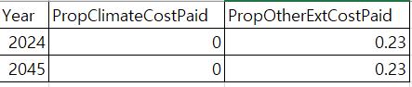
Possible Scenario
The document Task 7.2 Simplified Scenario Development guide, available at A Playbook for Simplified Approaches for Creating Scenarios in VisionEval, does not explicitly reference this file. However, adjusting the values could intuitively affect travel behavior and transportation-related outcomes. For example, increasing the proportion of external costs borne by individuals could increase the cost of driving. As a result, the model would be expected to show changes in outcomes such as DVMT, mode choice, congestion and delay.

Method Used for Virginia
Base Year
Currently, there are no carbon-related taxes in Virginia. Although fuel taxes do exist, according to the Code of Virginia, these revenues are primarily allocated to transportation improvement and operation—not to climate change mitigation. Accordingly, the value for the base year was set to 0.
According to The Economic and Societal Impact of Motor Vehicle Crashes, 2019 (Revised February 2023), USDOT, 23.29% of the economic cost was borne by individuals ("Self"). Although this figure is based on 2019 data, it was used for both the base year (2024) and the target year (2045) due to the lack of more recent or alternative data sources. Since this value does not fully capture all other external costs, adjustments may be necessary at the discretion of the analyst, depending on future data availability or contextual needs.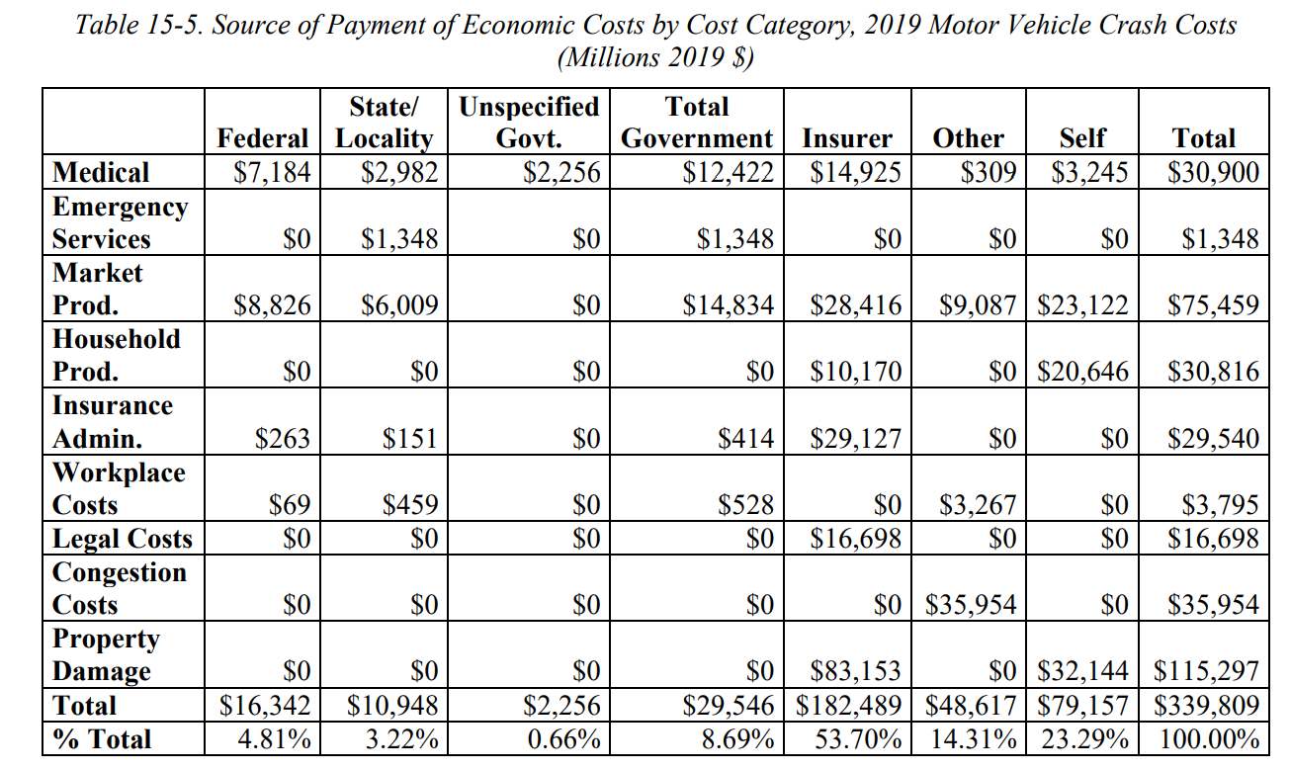

Forecast Year
Regarding the target-year value for PropClimateCostPaid, no plans to introduce a carbon tax in the future were identified in any available sources. Therefore, the target-year value was also set to 0.
Regarding the PropOtherExtCostPaid value, the same value as the base year was used due to the lack of available data sources.

Appendix 1: Data Sources
The Economic and Societal Impact of Motor Vehicle Crashes, 2019 (Revised February 2023), USDOT

Note: If a carbon tax is introduced in the future, the proportion of the social cost borne by individuals can be estimated with reference to the table below, sourced from “Report on the Social Cost of Greenhouse Gases: Estimates Incorporating Recent Scientific Advances,” EPA, November 2023.
